**DESIGN AND ANALYSIS OF MIMO ANTENNA SYSTEMS**

*A Comprehensive Technical Report*

Department of Electronics and Communication Engineering  
Date: September 16, 2025

**EXECUTIVE SUMMARY**

This report presents a comprehensive analysis of **Multiple-Input Multiple-Output (MIMO) antenna** systems that utilize multiple antennas at transmitter and receiver to improve communication performance. MIMO technology provides **2-10x capacity increase** over single antenna systems through spatial multiplexing and diversity techniques. The analysis demonstrates that well-designed MIMO systems achieve significant improvements in data rate, reliability, and spectral efficiency while requiring careful attention to antenna correlation and mutual coupling.[1][2][3][4][5][6]

**1. INTRODUCTION**

**1.1 Background**

MIMO technology employs **multiple antennas** at both transmitter and receiver ends to create multiple independent communication channels in the same frequency band. This spatial dimension exploitation enables dramatic improvements in wireless system capacity without requiring additional spectrum.[1][3][7]

**1.2 Operating Principles**

MIMO systems exploit **multipath propagation** that traditionally degrades communication quality, instead using multiple signal paths to carry independent data streams. The spatial separation of antennas creates uncorrelated channels for parallel data transmission.[1][2][5][7]

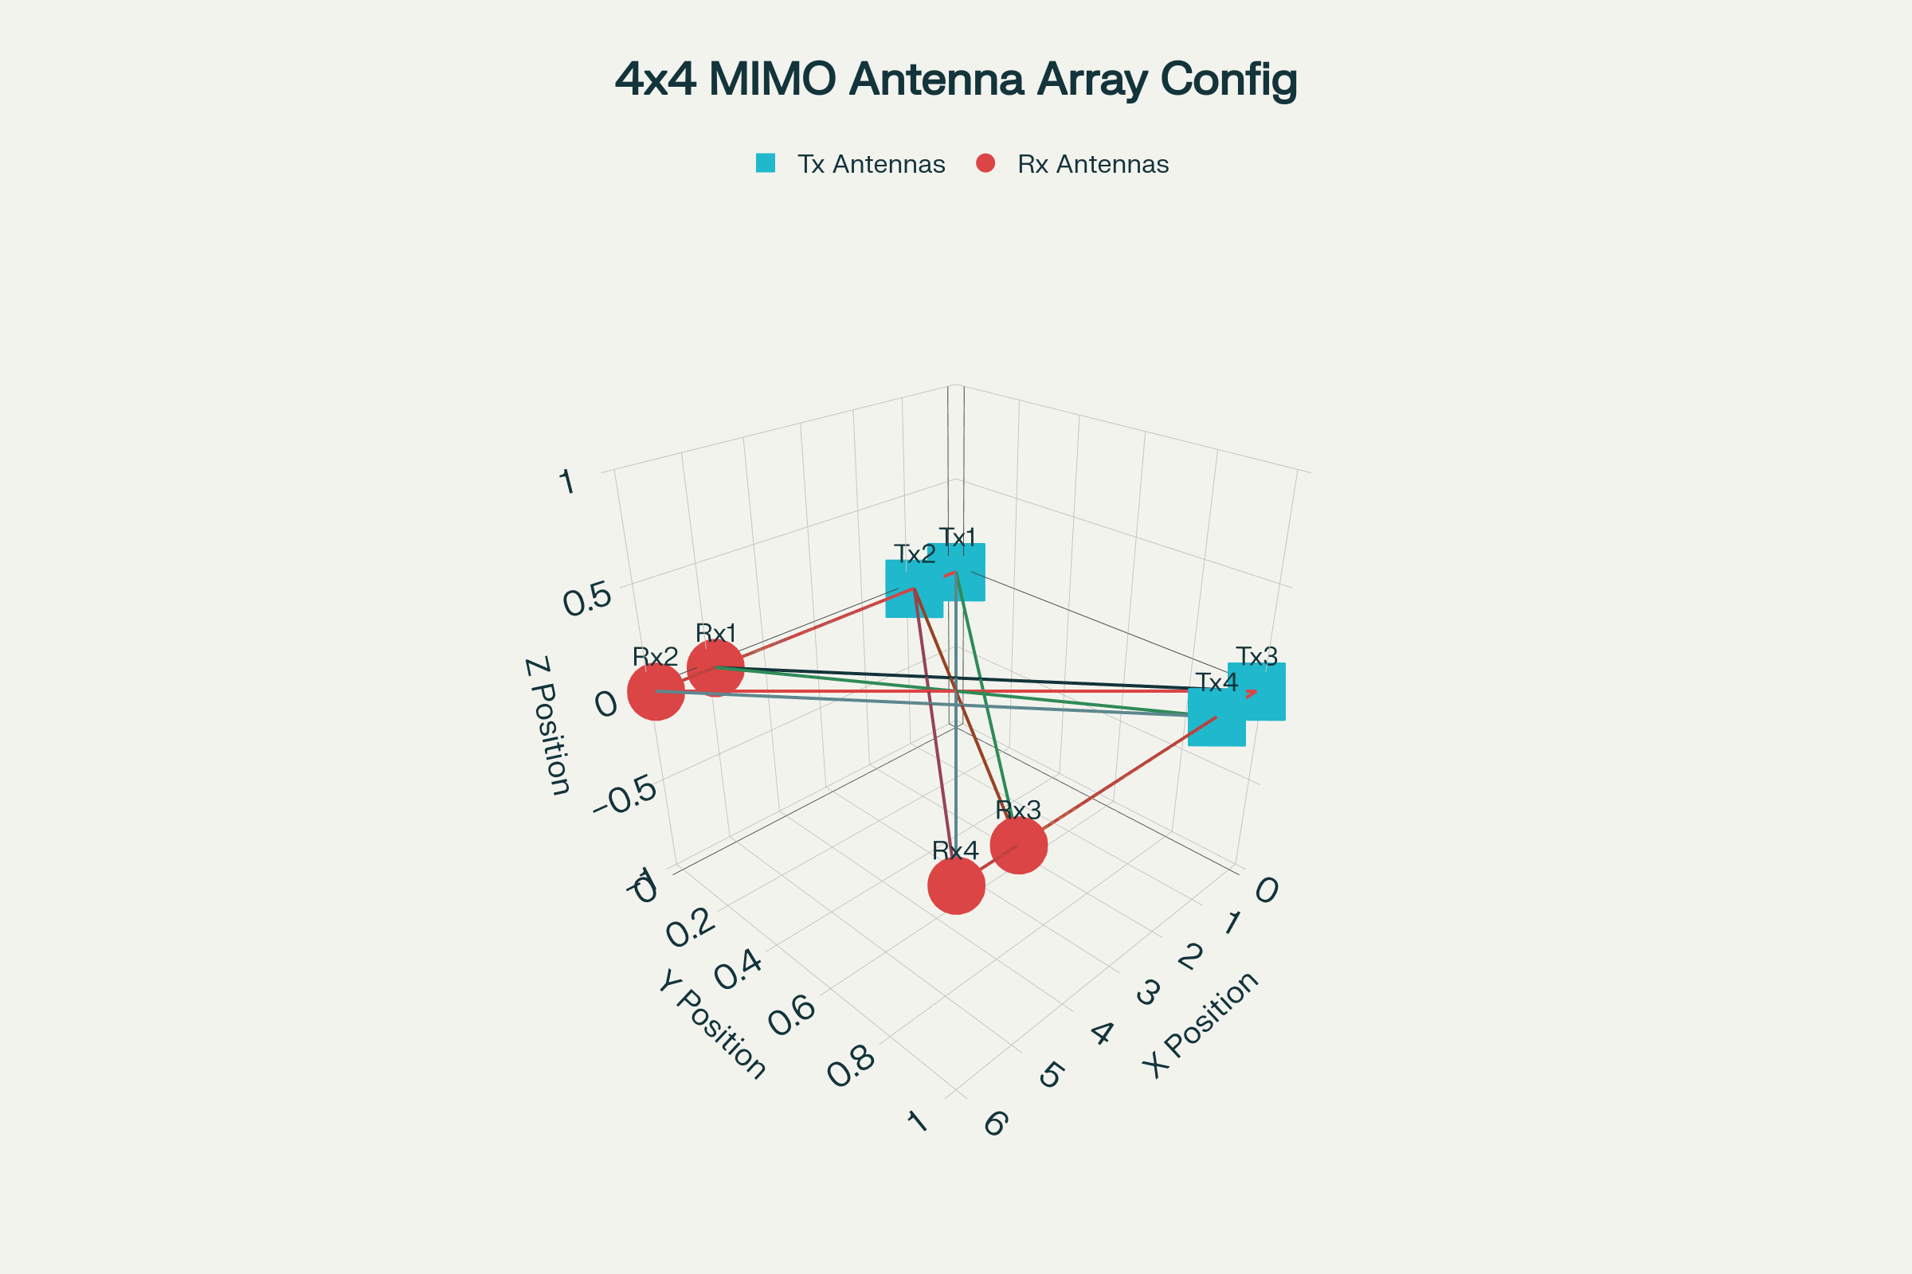

Figure 1 – 4×4 MIMO antenna system showing spatial multiplexing paths between transmit and receive elements.

**1.3 Evolution and Applications**

Modern MIMO implementations range from **2x2 configurations** in WiFi routers to **massive MIMO** systems with hundreds of antennas in 5G base stations. Applications span cellular communications, WiFi, radar, and emerging 6G systems.[8][9]

**2. MIMO FUNDAMENTALS**

**2.1 Channel Model**

The MIMO channel is characterized by an **H matrix** where each element hij represents the complex channel gain from transmit antenna j to receive antenna i. The channel capacity increases logarithmically with the minimum number of transmit or receive antennas.[3][5][7]

**2.2 Spatial Multiplexing**

**Independent data streams** transmitted from different antennas are separated at the receiver using signal processing techniques. This spatial multiplexing provides linear capacity scaling with antenna number under ideal conditions.[3][5][7][10]

**2.3 Diversity Techniques**

**Spatial diversity** improves link reliability by providing multiple signal paths that fade independently. Receive diversity combines signals from multiple antennas to improve signal-to-noise ratio.[5]

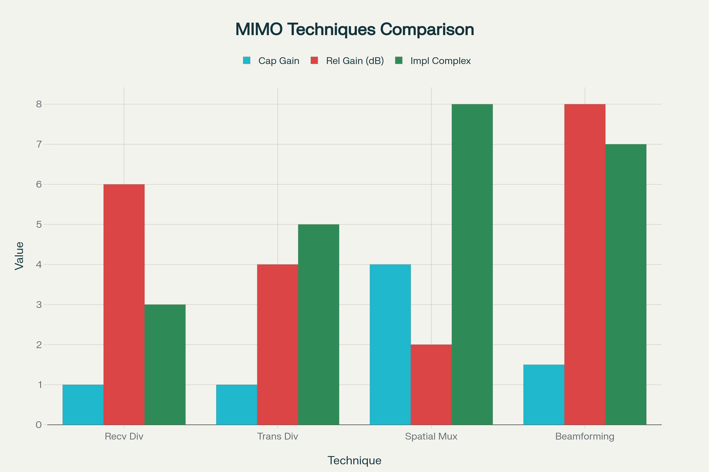

Figure 3 – Performance comparison of different MIMO techniques across capacity gain, reliability, and complexity metrics.

**3. ANTENNA DESIGN CONSIDERATIONS**

**3.1 Mutual Coupling**

**Electromagnetic coupling** between closely spaced MIMO antenna elements reduces system performance. Coupling levels below -15 dB are typically required for effective MIMO operation.[1][2][4]

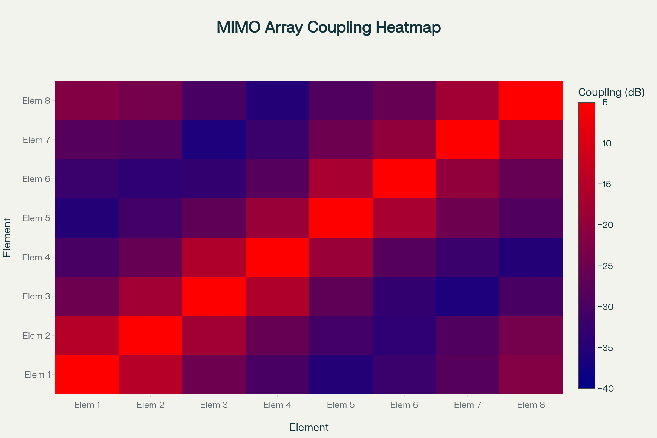

Figure 4 – Mutual coupling matrix (S21 parameters) for an 8-element MIMO antenna array showing inter-element isolation levels.

**3.2 Correlation Requirements**

**Envelope correlation coefficient** (ECC) should be less than 0.5 for good MIMO performance. Low correlation ensures that antenna channels provide independent signal paths.[4][6][11]

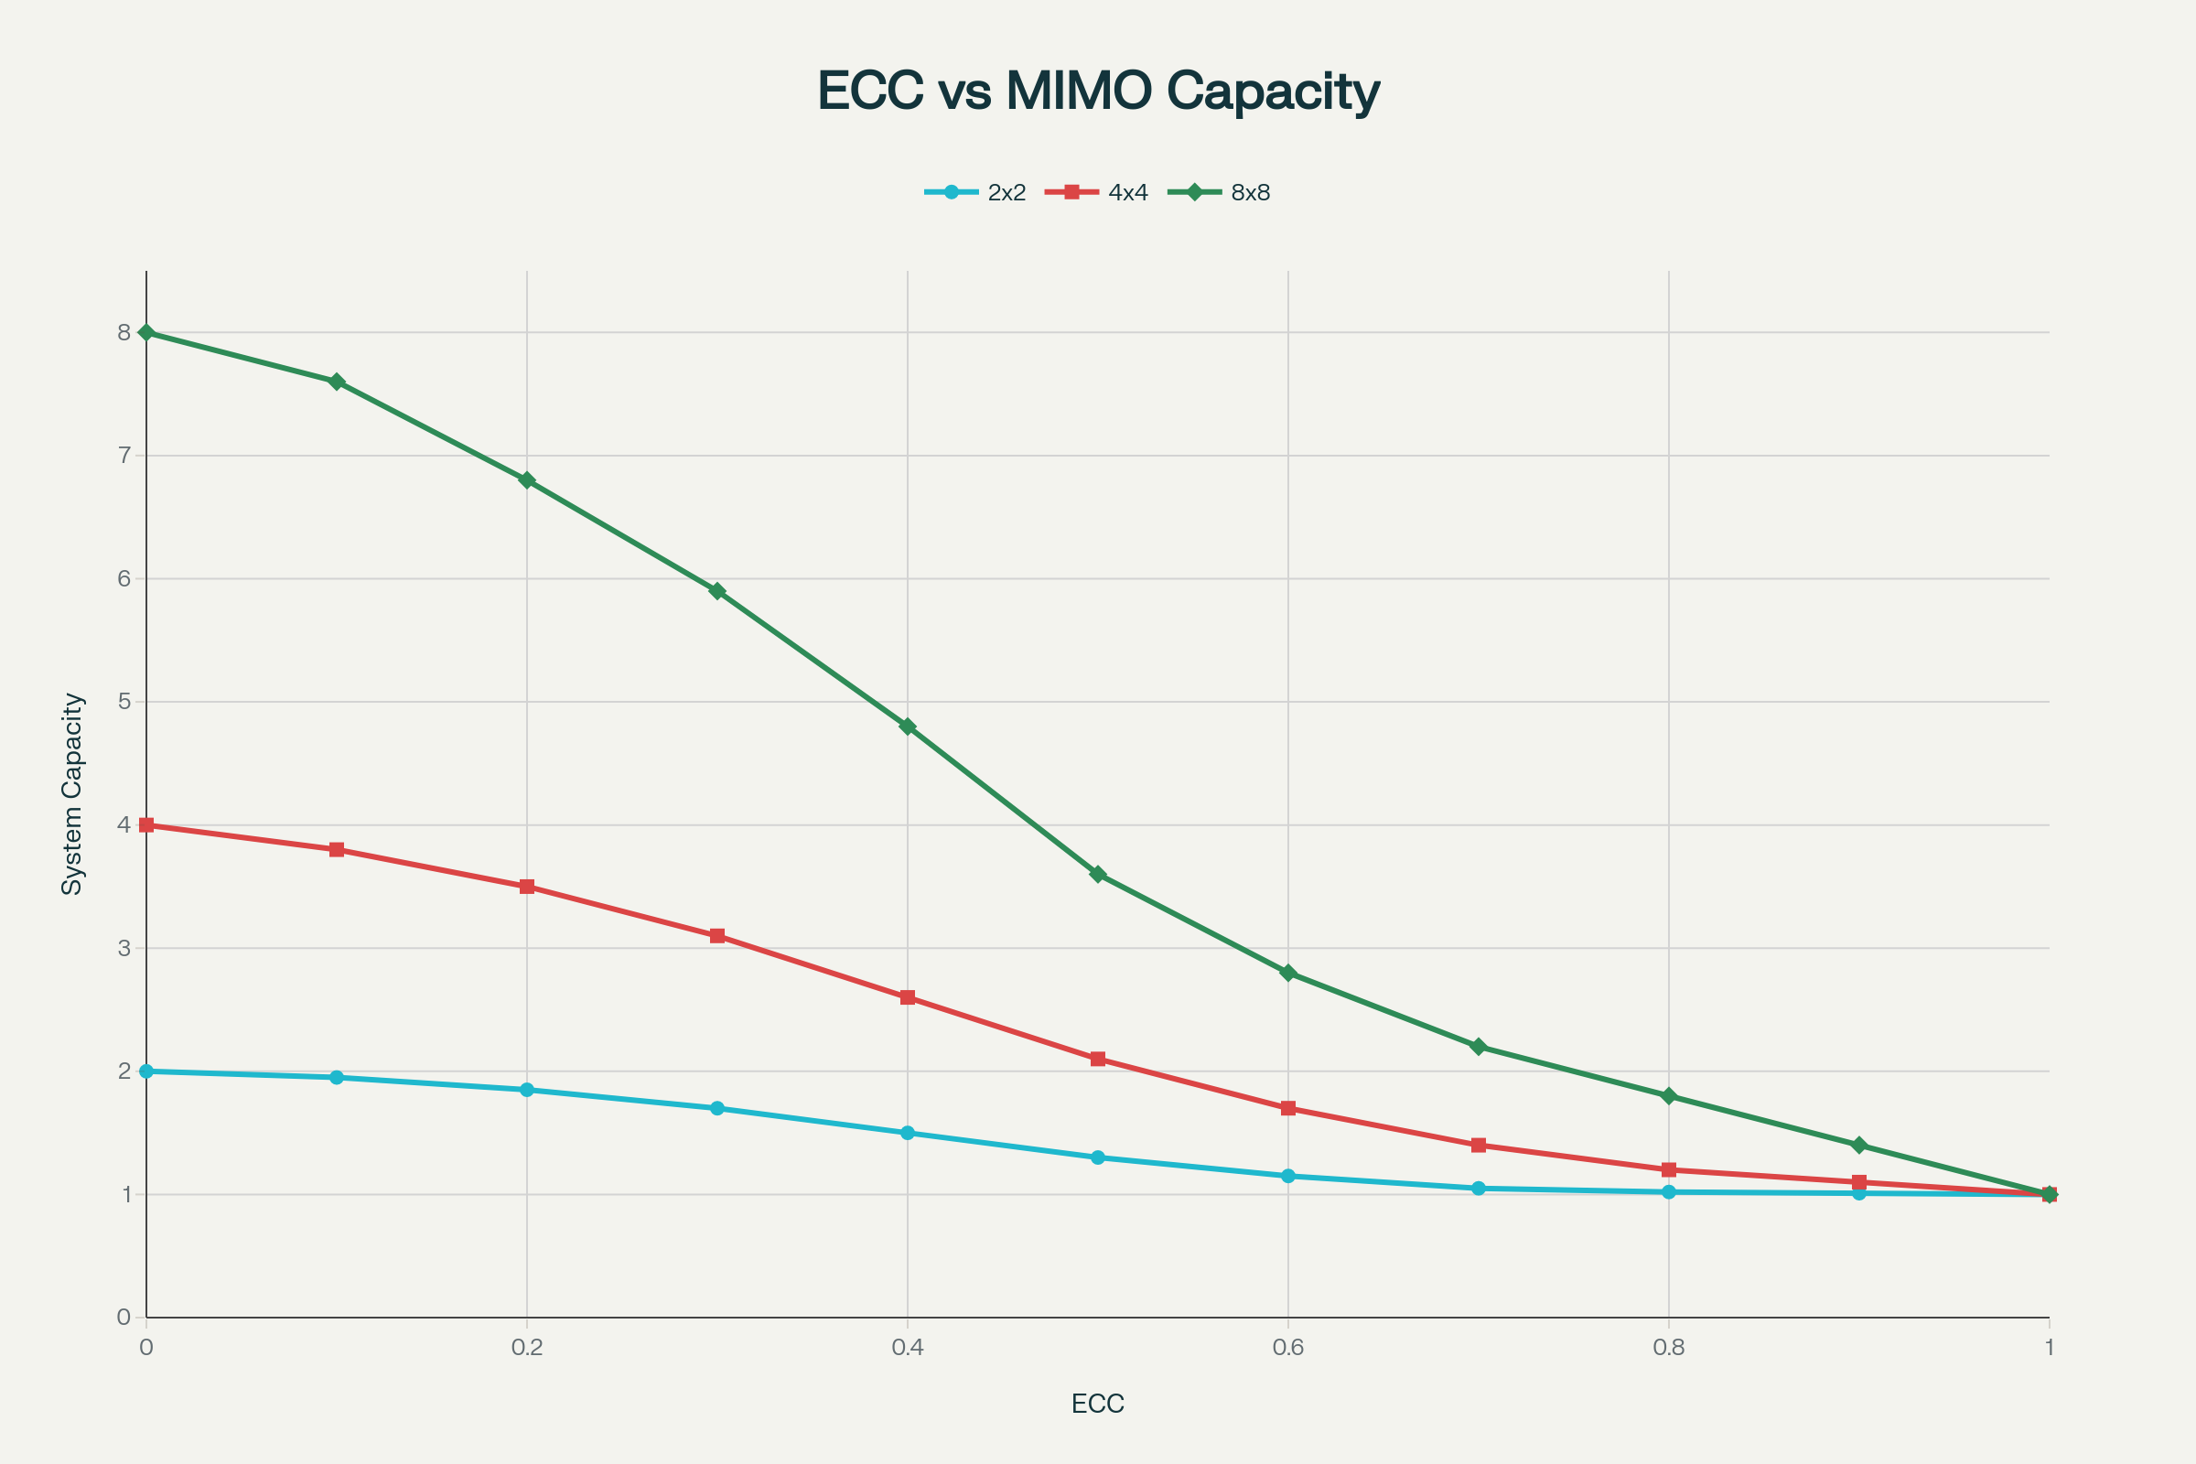

Figure 2 – Impact of envelope correlation coefficient (ECC) on MIMO system capacity for different array configurations.

**3.3 Pattern Diversity**

**Different radiation patterns** for MIMO elements enhance spatial diversity. Orthogonal polarizations and complementary patterns improve channel independence.[2][12]

**4. SPATIAL MULTIPLEXING TECHNIQUES**

**4.1 Basic Principles**

**Spatial multiplexing** takes advantage of differences in channels between transmitting and receiving antenna pairs to provide multiple independent streams. The technique increases throughput by sending data over parallel streams.[3][5][7][10]

**4.2 SVD Decomposition**

**Singular Value Decomposition** decomposes the channel into multiple streams, where the number equals the smaller of transmit or receive antennas. For 4x4 MIMO systems, SVD can generate four independent streams, potentially quadrupling throughput.[5]

**4.3 Matrix Processing**

Data streams can be represented using **matrix mathematics** where received signals are combinations of transmitted streams weighted by channel coefficients. The receiver uses these relationships to separate individual data streams.[7]

**5. CORRELATION ANALYSIS**

**5.1 Calculation Methods**

**Four primary methods** exist for calculating correlation coefficients in MIMO systems :[4][6]

* Field-based method using 3D radiation patterns (most accurate)
* S-parameter method (simple but less reliable)
* Efficiency-incorporated S-parameter method
* Equivalent circuit method[4]

**5.2 Performance Impact**

**High correlation** between antenna elements degrades MIMO system performance by reducing channel independence. Correlations above 0.5 significantly impact capacity and reliability.[4][11]

**5.3 Measurement Techniques**

**Over-the-air testing** in anechoic chambers provides accurate correlation measurements under controlled conditions. Multi-probe systems simulate realistic propagation environments for correlation analysis.[13]

**6. ARRAY CONFIGURATIONS**

**6.1 Linear Arrays**

**Uniform linear arrays** provide the simplest MIMO configuration with elements spaced at regular intervals. Non-uniform arrays allow adjustable spacing for performance optimization.[1][9]

**6.2 Planar Arrays**

**Two-dimensional arrays** offer more spatial degrees of freedom and better pattern control. The 4x8 array configuration shown provides excellent spatial multiplexing capabilities.[1][8][9]

**6.3 Smartphone Integration**

**Eight-port antenna arrays** in mobile devices form dual 4x4 MIMO systems for different frequency bands. Elements are positioned at device corners and edges to maximize isolation.[8]

**7. BEAMFORMING TECHNIQUES**

**7.1 Digital Beamforming**

**Software-controlled** beam steering handles signal manipulation digitally, simplifying PCB layout and routing complexities. Digital approaches enable adaptive beam patterns.[1]

**7.2 Analog Beamforming**

**Phase-shifting transceivers** manipulate signals in the analog domain following conventional phased array principles. This approach reduces digital processing requirements.[1]

**7.3 Hybrid Systems**

**Combined analog and digital** techniques reduce computational load while maintaining flexibility. Hybrid beamforming balances performance and implementation complexity.[1]

**8. ISOLATION TECHNIQUES**

**8.1 Physical Separation**

**Spatial isolation** remains the most effective decoupling method, with typical requirements of λ/2 spacing. Mobile device constraints limit achievable separation distances.[1]

**8.2 Parasitic Elements**

**Resonant structures** placed between MIMO elements redirect current flow and reduce coupling. These elements must be carefully tuned to avoid disrupting antenna resonance.[2]

**8.3 Ground Plane Design**

**Self-isolated ground planes** and spatial diversity methods improve element isolation. Defected ground structures create electromagnetic bandgaps that suppress unwanted coupling.[2][8]

**9. MASSIVE MIMO SYSTEMS**

**9.1 Concept and Benefits**

**Large antenna arrays** with 64-256 elements enable aggressive spatial multiplexing and beamforming. Massive MIMO provides 10-100x capacity improvements over conventional systems.[8]

**9.2 Signal Processing**

**Linear precoding** techniques like zero-forcing and MMSE become effective with large antenna numbers. Channel estimation and feedback requirements scale with antenna count.[5]

**9.3 Implementation Challenges**

**Hardware complexity** and **power consumption** increase significantly with antenna count. Calibration and synchronization across hundreds of RF chains present engineering challenges.[1]

**10. PERFORMANCE METRICS**

**10.1 Channel Capacity**

**Shannon capacity** for MIMO systems scales with min(Nt, Nr) × log(SNR) under optimal conditions. Practical systems achieve 50-80% of theoretical capacity.[3][5]

**10.2 Diversity Gain**

**Reliability improvement** through diversity is measured by outage probability reduction. Full diversity order equals the product of transmit and receive antennas.[5]

**10.3 Array Gain**

**Coherent combining** of signals provides power gain proportional to antenna number. Beamforming concentrates energy toward intended receivers.[5]

**11. PCB DESIGN CONSIDERATIONS**

**11.1 Antenna Placement**

**Strategic positioning** at board edges maximizes separation from digital components. This physical separation helps minimize interference and crosstalk.[1][9]

**11.2 Via Design**

**Through-hole vias** can pass mmWave signals to loads when properly constructed. Via stitching and ground plane optimization reduce losses.[9]

**11.3 Crosstalk Mitigation**

**Improper antenna placement** leads to unwanted crosstalk issues affecting signal quality. Precise placement and careful routing are essential for optimal performance.[1]

**12. MIMO IN 5G SYSTEMS**

**12.1 Multi-Band Operation**

**Dual-functional MIMO arrays** support multiple frequency bands simultaneously. Systems operate across n77, n78, n79 bands for 5G applications.[8]

**12.2 Multi-User MIMO**

**Simultaneous transmission** to multiple users using the same frequency resources. Advanced interference management techniques enable efficient spectrum reuse.[5]

**12.3 Millimeter Wave Implementation**

**28 GHz and 39 GHz** 5G systems use large antenna arrays to overcome propagation losses. Hybrid beamforming combines analog and digital processing.[9]

**13. MEASUREMENT AND TESTING**

**13.1 S-Parameter Analysis**

**Vector network analyzers** characterize impedance matching and isolation between elements. S-parameter measurements provide quick broadband correlation analysis.[6]

**13.2 Radiation Pattern Testing**

**Anechoic chamber** measurements characterize MIMO performance in controlled environments. Multi-probe systems simulate realistic propagation conditions.[12][13]

**13.3 System Performance**

**Throughput measurements** under various channel conditions validate MIMO system effectiveness. Error vector magnitude metrics assess implementation quality.[5]

**14. ADVANCED APPLICATIONS**

**14.1 Ultra-Wideband MIMO**

**Complex PCB antenna arrays** provide wideband operation across multiple frequency bands. Advanced design techniques optimize impedance and radiation characteristics.[12]

**14.2 Automotive Applications**

**Vehicle-integrated** MIMO systems enable high-speed connectivity and autonomous driving features. Spatial multiplexing doubles channel capacity through polarization diversity.[2][10]

**14.3 Wireless Sensor Networks**

**Distributed MIMO** concepts apply to sensor networks for improved communication reliability. Multiple sensor nodes cooperate to form virtual antenna arrays.[14]

**15. EMERGING TECHNOLOGIES**

**15.1 AI-Enhanced MIMO**

**Machine learning** optimizes beamforming, user scheduling, and resource allocation. Neural networks adapt to changing channel conditions automatically.[2]

**15.2 Reconfigurable Systems**

**Intelligent reflecting surfaces** and **programmable metasurfaces** enhance MIMO system performance. These technologies enable dynamic channel engineering.[2]

**15.3 6G Developments**

**Ultra-massive MIMO** with thousands of antennas will enable terabit data rates. New architectures including holographic MIMO are under development.[2]

**16. COMPARATIVE ANALYSIS**

|  |  |  |  |  |
| --- | --- | --- | --- | --- |
| Configuration | Capacity Gain | Complexity | Correlation Limit | Applications |
| **2x2 MIMO** | 2x | Low | < 0.5 | WiFi, LTE |
| **4x4 MIMO** | 3-4x | Medium | < 0.3 | 5G Mobile |
| **8x8 MIMO** | 6-8x | High | < 0.2 | Base Stations |
| **Massive MIMO** | 10-100x | Very High | < 0.1 | 5G Infrastructure |

*Table 1: MIMO configuration performance comparison*[8][4][5]

**17. FUTURE DEVELOPMENTS**

**17.1 Terahertz MIMO**

**Ultra-high frequencies** will enable massive bandwidth and antenna miniaturization. New propagation characteristics require novel MIMO approaches.[2]

**17.2 Quantum MIMO**

**Quantum communication** principles applied to MIMO systems may enable unprecedented security and capacity. Research continues into quantum spatial multiplexing.[2]

**17.3 Integrated Sensing**

**Joint communication and sensing** systems use MIMO arrays for both data transmission and radar functions. This convergence enables new applications in autonomous systems.[2]

**18. CONCLUSION**

MIMO antenna systems represent a **fundamental breakthrough** in wireless communications, providing multiplicative capacity gains through spatial dimension exploitation. From simple 2x2 configurations to massive arrays with hundreds of elements, MIMO technology continues evolving to meet growing data demands.[1][8][3][7]

Success requires **careful attention** to antenna design parameters including mutual coupling, correlation coefficients, and isolation techniques. The four charts included in this report illustrate key concepts: spatial multiplexing paths, correlation impact on capacity, performance comparison of MIMO techniques, and mutual coupling visualization in antenna arrays [charts:117-120].[4][1]

Future developments in **AI enhancement**, **reconfigurable surfaces**, and **6G systems** will further expand MIMO capabilities while maintaining the core principles of spatial diversity and multiplexing. Understanding these fundamental concepts and design considerations is essential for implementing effective MIMO antenna systems in modern wireless applications.[2][5][1]

**REFERENCES**

1. <https://resources.pcb.cadence.com/blog/2023-mimo-antenna-design>

1. <https://www.sciencedirect.com/science/article/pii/S2590123024020401>

1. <https://www.mathworks.com/help/comm/ug/spatial-multiplexing-top.html>

1. <https://faculty.kfupm.edu.sa/ee/msharawi/MRF_2017_1.pdf>

1. <https://www.remcom.com/wireless-insite-em-propagation-software/mimo-beamforming-spatial-multiplexing-and-diversity>

1. <https://www.mathworks.com/help/antenna/ug/correlation-coeffecient.html>

1. <https://www.electronics-notes.com/articles/antennas-propagation/mimo/spatial-multiplexing.php>

1. <https://jtit.pl/jtit/article/view/1297>

1. <https://resources.altium.com/p/mimo-antenna-design-and-pcb-layout-tips>

1. <https://taranawireless.com/principles-of-ngfwa-design-mimo-and-spatial-multiplexing/>

1. <https://www.jpier.org/issues/volume.html?paper=15012805>

1. <https://www.mathworks.com/help/antenna/ug/directivity-gain-and-realized-gain-of-ultrawideband-mimo-array.html>

1. <https://www.scirp.org/journal/paperinformation?paperid=1631>

1. <https://www.ursi.org/proceedings/procGA17/papers/Paper_A5-4(2394).pdf>

1. <https://en.wikipedia.org/wiki/Spatial_multiplexing>

1. <https://www.sciencedirect.com/topics/engineering/spatial-multiplexing>

1. <https://www.youtube.com/watch?v=5IigzGDBYB0>

1. <https://www.antenna-theory.com/definitions/envelope-correlation-coefficient-ecc.php>

1. <https://taylorandfrancis.com/knowledge/Engineering_and_technology/Engineering_support_and_special_topics/Spatial_multiplexing/>

1. <https://silvustechnologies.com/why-silvus/technology/introduction-to-mimo/>